Lab # 04
IMPLEMENTATION OF DFS & BFS ALGORITHMS IN PYTHON
Objective:
- To implement depth first search algorithm using python.
- To implement breath first search algorithm using python.
Lab Related Theory:
Depth First Search Algorithm
Depth First Search (DFS) algorithm traverses a graph in a deathwards motion and uses a stack to remember to get the next vertex to start a search, when a dead end occurs in any iteration.
It employs the following rules.
- Rule 1 − Visit the adjacent unvisited vertex. Mark it as visited. Display it. Push it in a stack.
- Rule 2 − If no adjacent vertex is found, pop up a vertex from the stack. (It will pop up all the vertices from the stack, which do not have adjacent vertices.)
- Rule 3 − Repeat Rule 1 and Rule 2 until the stack is empty.
Let’s take an example
Step | Traversal | Description
1. | 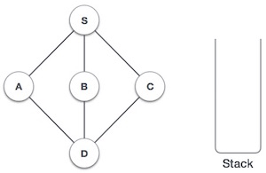 | Initialize the stack.
2. | 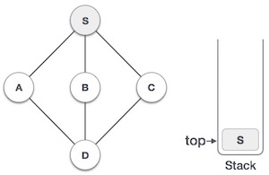 | Mark S as visited and put it onto the stack. Explore any unvisited adjacent node from S. We have three nodes and we can pick any of them. For this example, we shall take the node in an alphabetical order.
3. | 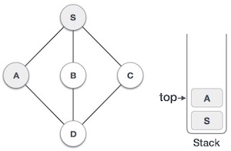 | Mark A as visited and put it onto the stack. Explore any unvisited adjacent node from A. Both Sand D are adjacent to A but we are concerned for unvisited nodes only.
4. | 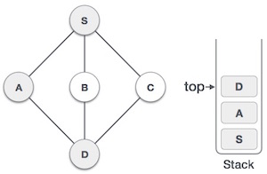 | Visit D and mark it as visited and put onto the stack. Here, we have B and C nodes, which are adjacent to D and both are unvisited. However, we shall again choose in an alphabetical order.
5. | 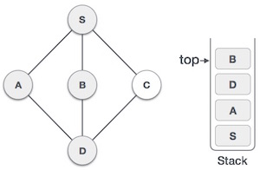 | We choose B, mark it as visited and put onto the stack. Here Bdoes not have any unvisited adjacent node. So, we pop Bfrom the stack.
6. | 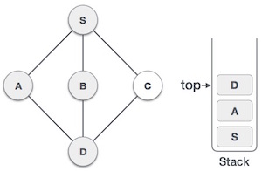 | We check the stack top for return to the previous node and check if it has any unvisited nodes. Here, we find D to be on the top of the stack.
7. | 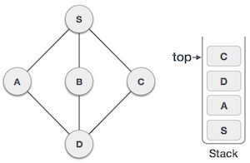 | Only unvisited adjacent node is from D is C now. So we visit C, mark it as visited and put it onto the stack.
The Graph
Graph can be initialized in Python as:
graph = {'S': set(['A', 'C',’B’]),
'C': set(['D']),
'A': set(['S', 'D']),
'D': set(['B']),
'B': set(['S']),
}
Looking at the graph depiction below you will also notice the inclusion of a cycle, by the adjacent connections . This has been purposely included to provide the algorithms with the option to return
multiple paths between two desired nodes.
Procedure:
Depth-First search explores possible vertices (from a supplied root) down each branch before backtracking. This property allows the algorithm to be implemented succinctly in both iterative and recursive forms. Below is a listing of the actions performed upon each visit to a node.
- Mark the current vertex as being visited.
- Explore each adjacent vertex that is not included in the visited set.

Connected Component
The implementation below uses the stack data-structure to build-up and return a set of vertices that are accessible within the subjects connected component. Using Python’s overloading of the subtraction operator to remove items from a set, we are able to add only the unvisited adjacent vertices.
http://eddmann.com/posts/depth-first-search-and-breadth-first-search-in-python/
Code :
This code will visit each node and mark it as visited.
graph = {'S': set(['A', 'C','B']),
'C': set(['D']),
'A': set(['D']),
'D': set(['B']),
'B': set(['S'])
}
def dfs(graph, start):
visited, stack = set(), [start]
while stack:
vertex = stack.pop()
if vertex not in visited:
visited.add(vertex)
stack.extend(graph[vertex] - visited)
return visited
print(dfs(graph, 'S'))
Code 2:
DFS algorithm is also used for detecting best possible path from start to goal.
graph = {'S': set(['A', 'C','B']),
'C': set(['D']),
'A': set(['S', 'D']),
'D': set(['B']),
'B': set(['S']),
}
def dfs_paths(graph, start, goal):
stack = [(start, [start])]
while stack:
(vertex, path) = stack.pop()
for next in graph[vertex] - set(path):
if next == goal:
yield path + [next]
else:
stack.append((next, path + [next]))

print(list(dfs_paths(graph, 'S', 'D')))

Breadth First Traversal or BFS for a Graph
Return the shortest path between two nodes of a graph using BFS, with the distance measured in number of edges that separate two vertices.
Breadth First Search (BFS) algorithm traverses a graph in a breadth ward motion and uses a queue to remember to get the next vertex to start a search, when a dead end occurs in any iteration.
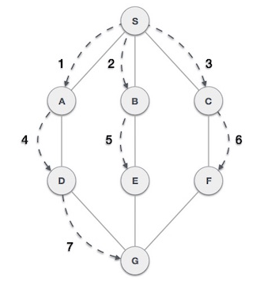

As in the example given above, BFS algorithm traverses from A to G in the above mentioned order. It employs the following rules.
- Rule 1 − Visit the adjacent unvisited vertex. Mark it as visited. Display it. Insert it in a queue.
- Rule 2 − If no adjacent vertex is found, remove the first vertex from the queue.
- Rule 3 − Repeat Rule 1 and Rule 2 until the queue is empty.
Step | Traversal | Description
1. | 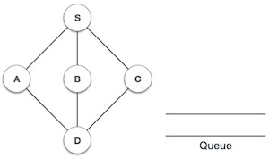 | Initialize the queue.
2. | 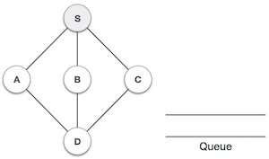 | We start from visiting S(starting node), and mark it as visited.
3. | 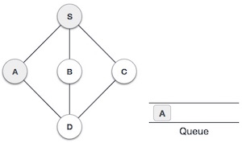 | We then see an unvisited adjacent node from S. In this example, we have three nodes but alphabetically we choose A, mark it as visited and enqueue it.
4. | 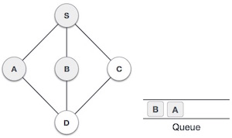 | Next, the unvisited adjacent node from S is B. We mark it as visited and enqueue it.
5. | 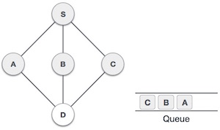 | Next, the unvisited adjacent node from S is C. We mark it as visited and enqueue it.
6. | 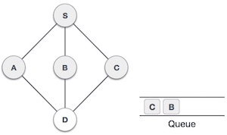 | Now, S is left with no unvisited adjacent nodes. So, we dequeue and find A.
7. | 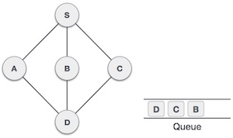 | From A we have D as unvisited adjacent node. We mark it as visited and enqueue it.
Code (visits all the nodes of a graph)
# sample graph implementation
graph = {'A': ['B', 'C', 'E'],
'B': ['A','D', 'E'],
'C': ['A', 'F', 'G'],
'D': ['B'],
'E': ['A', 'B','D'],
'F': ['C'],
'G': ['C']}
# visits all the nodes of a graph (connected component) using BFS
def bfs_connected_component(graph, start):
# keep track of all visited nodes
explored = []
# keep track of nodes to be checked
queue = [start]
# keep looping until there are nodes still to be checked
while queue:
# pop shallowest node (first node) from queue
node = queue.pop(0)
if node not in explored:
# add node to list of checked nodes
explored.append(node)
neighbours = graph[node]
# add neighbours of node to queue
for neighbour in neighbours:
queue.append(neighbour)
return explored
print(bfs_connected_component(graph,'A')) # returns ['A', 'B', 'C', 'E', 'D', 'F', 'G']
Code: Find shortest path b/w two nodes.
def bfs_shortest_path(graph, start, goal):
# keep track of explored nodes
explored = []
# keep track of all the paths to be checked
queue = [[start]]
# return path if start is goal
if start == goal:
return "That was easy! Start = goal"
# keeps looping until all possible paths have been checked
while queue:
# pop the first path from the queue
path = queue.pop(0)
# get the last node from the path
node = path[-1]
if node not in explored:
neighbours = graph[node]
# go through all neighbour nodes, construct a new path and
# push it into the queue
for neighbour in neighbours:
new_path = list(path)
new_path.append(neighbour)
queue.append(new_path)
# return path if neighbour is goal
if neighbour == goal:
return new_path
# mark node as explored
explored.append(node)
# in case there's no path between the 2 nodes
return "So sorry, but a connecting path doesn't exist :("
print(bfs_shortest_path(graph, 'G', 'D')) # returns ['G', 'C', 'A', 'B', 'D']

LAB EXERCISE:
Q1- Implement both DFS and BFS algorithm using Python. Understand the procedure of BFS and DFS with relevance to code. Attach well commented code and output.
Learning Outcomes:

In this lab we implement DFS and BFS using python and understand there procedure

